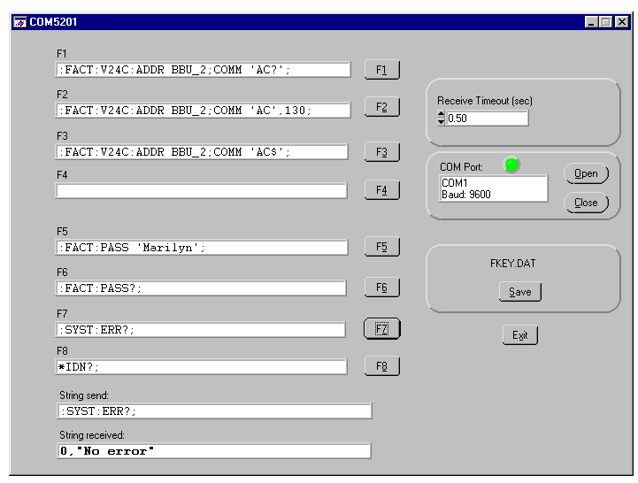
Adjustment of DC-offset on PT8631

